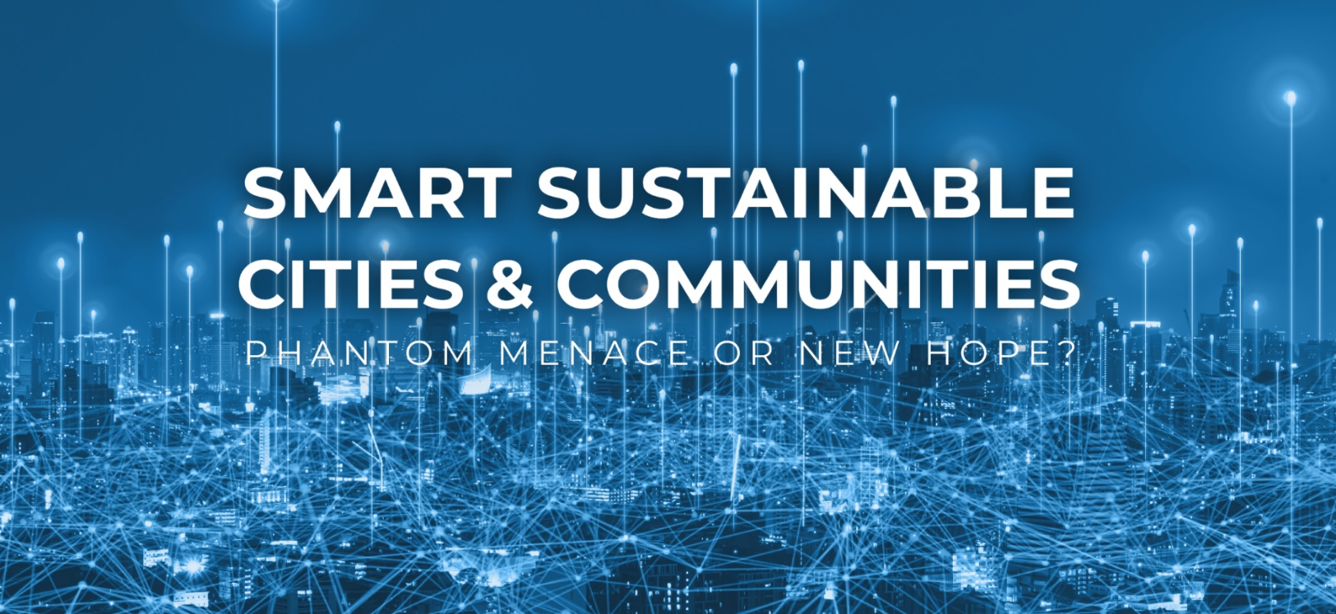

The Rules and Regulations of
ENHANCE SMART SUSTAINABLE CITIES & COMMUNITIES COMPETITION
Edition 2023

- General provisions
- These rules and regulations, hereinafter referred to as the Regulations, set out the terms and conditions for the ENHANCE SMART SUSTAINABLE CITIES & COMMUNITIES competition to be held as the part of the European Universities of Technology ENHANCE Alliance activity in Warsaw on the 19th May, 2023, and it will constitute the part of the Student-designed exhibition on Smart Sustainable Cities.
- The Organizer of the competition is the Warsaw University of Technology, with its registered office in Warsaw, 00-661, Pl. Politechniki 1, NIP 525-00-05-834.
- The competition is team-based.
- The requirements for the participation in the competition:
- the Participant’s participation in the ENHANCE SMART SUSTAINABLE CITIES & COMMUNITIES workshop called “Phantom menace or new hope” held from the 1st March 2023 to 19th May 2023.
- submission by the Participant of the statement that he/she is familiar with the Regulations of the ENHANCE SMART SUSTAINABLE CITIES & COMMUNITIES Competition, enclosed as the Appendix 1 to the Regulations.
- Participation in the competition is voluntary and free of charge.
- The decisions of the Organizer are final and cannot be appealed otherwise.

- The objective of the competition
- The main objective of the competition is for the Participants to promote new urban solutions in which economic and social prosperity is built and the rights of residents are respected. At the same time, development and urban planning are economically justified and shaped on the basis of sustainability and ecological solutions.
- The objective of the Competition is for Competition teams to create the prototype of a solution that is in accordance with the idea of smart, sustainable cities in the broadest sense according to the criteria outlined in Part IV of the Rules.
- The evaluation is based on the prototype solution and its presentation to the Jury.
- The competition is conducted exclusively in English. The required language level of the Entrant is at least B2 according to CEFR (link: https://www.coe.int/en/web/common-european-framework-reference-languages/level-descriptions)

- Participants
- Participants in the competition are second- and third-level students of ENHANCE Alliance partner universities, i.e. Norwegian University of Science and Technology (NTNU), Rhine-Westphalia Technical University of Aachen (RWTH), Technische Universität Berlin (TUB), Universitat Politècnica de València (UPV), Chalmers University of Science and Technology (Chalmers), Warsaw University of Technology (WUT) and universities associated with the Alliance, i.e. the Lviv Polytechnic National University and the National Technical University of Ukraine Igor Sikorsky Kyiv Polytechnic Institute, hereinafter referred to as Participants.
- The competition is a team competition with the teams consisting of teams of 2-4 Participants, hereinafter referred to as Competition Teams.
- Competition teams are supported with office and tool materials needed for prototyping.
- Each Participant is required to provide the free of charge consent, without any time or territorial limitations, concerning using the material submitted /including video and the image from the photographs taken during competition by the Organizer or particular Partners/ for marketing and promotional activities of the Organizer, Partners and ENHANCE Alliance, i.e. for publishing the video and the pictures on the competition website or Alliance website, in advertising and promotional materials and on social media channels of the particular Partners and ENHANCE Alliance.

- Assessement criteria
- Each Competition Team makes the presentation of their prototype during the pitching session. The presentation lasts the maximum of 5 minutes.
- All prototypes and presentations needs to meet the ethical standards regarding the language, the visual content and the intellectual property rights. The failure to meet these conditions will result in disqualification of the Team.
- The winners of the competition and the awarding of prizes shall be decided by the Jury of the competition, hereinafter referred to as the Jury, appointed for this purpose by the Organizer from among the representatives of the ENHANCE universities which Participants take part in the competition. The Jury is chaired by the representative of the Warsaw University of Technology.
- Each member of the Jury shall award points on the voting card, which is attached as Appendix 2 to the Regulations. The all awarded points on voting cards are then added up. The Competition Team whose prototype received the highest number of points wins.
- The Jury may award the award of distinction in recognition of the special creativity of the Competition Team.
- The Jury assesses the prototype solution and the way it is presented according to the following criteria:
- The Compliance with the Sustainable Development Goals (weight: 25%)
  - The compliance with the Sustainable Development Goals, in particular goals 3, 11, 13, 7 or 12
- Inclusiveness and social utility and the impact on the local environment (weight: 20%)
  - the identification of a social problem for the local population
  - the elimination of exclusions based on age, gender, health status, etc.
  - the development of the local community in the context of deliberative democracy
  - the impact of the proposed solution on the local environment
  - the impact of the technology used on environmental sustainability
- Innovation and technologies used (weight: 25%)
  - the level of innovation of the solution
  - the types of technologies involved in the Smart City concept and their application in the project
- Feasibility and implementability in other cities – genericity (weight: 10%)
  - the applicability and limitations of the idea
  - the quality of the business model
- Presentation of the prototype (weight: 20%)
  - the tools used to present the idea
  - the form of a presentation
- The decisions of the Jury shall be final and are not subject to any appeals.
- The Participants will be informed of the results of the competition immediately after the Jury’s decision is made on 19th May 2023.

- Awards
- The Organizer is the founder of the prizes in the competition.
- The awards in the competition:
  - the first place – the cash prize of EUR 2,000 (in words: two thousand EURO), paid in Polish zlotys at the average exchange rate of the National Bank of Poland on the day of the payment/transfer,
  - the award of distinction – a cash prize of EUR 1,000 (in words: one thousand EURO) paid out in Polish zlotys at the average exchange rate of the National Bank of Poland on the day of payment/transfer.
- The Jury retains the option of not awarding a distinction, in which case the 1st prize shall be increased to the amount of 3,000 EURO (three thousand EURO) paid in Polish zloty at the average exchange rate of the National Bank of Poland on the date of payment/transfer.
- Prizes to which the law provides tax liability shall be taxed in accordance with the applicable tax laws.
- The awarded prizes will be distributed according to their value in equal parts among the Participants of the awarded Competition Teams.
- The payment of prizes will be made by the bank transfer up to 14 days after the announcement of the competition results and under the condition of submitting the information necessary to make tax settlements by the members of the awarded Competition Teams.
- The results of the competition will be published by 23rd May 2023 on the Organiser's website ENHANCE Smart City (pw.edu.pl).
- The Organizer shall not be responsible for the failure or obstruction to collect the prize due to the reasons attributable to the Participant of the awarded Competition Team.

- Personal information
      - Warsaw University of Technology, located at Plac Politechniki 1, 00-661 Warsaw, is The Participants' personal data administrator.
      - The Administrator has appointed the Data Protection Inspector to supervise the processing of personal data. The Inspector can be contacted at the e-mail address: iod@pw.edu.pl.
      - The Personal data is processed on the basis of Article 6(1)(a) of Regulation (EU) 2016/679 of the European Parliament and of the Council of 27 April 2016 on the protection of natural persons with regard to the processing of personal data and on the free movement of such data and repealing Directive 95/46 / EC (Official Journal of the EU L 119/1 of 4 May 2016 - GDPR), i.e. on the basis of consent granted by the Contest Participant.
      - The Participant's personal data shall be processed in connection with their participation in the Competition, i.e. for the purpose of organizing the Competition, conducting the Competition, as well as transferring the prizes.
      - The Participant's personal data is stored for the duration of the Competition and for the period resulting from the archival regulations after the end of the Competition
      - Providing personal data is voluntary and is the condition of participating in the Competition and receiving the prize.
      - In connection with the processing of personal data, the Participant has the right to:
  - access to their data,
  - request their rectification,
  - request their deletion if it is determined that there are no grounds for the data to be processed,
  - demand restriction of their processing,
  - to object to the processing of data, the provision of which is voluntary,
  - data portability,
  - withdraw the consent to data processing at any time. The withdrawal of the consent will not affect the legal compliance of the data processing conducted t on the basis of the obtained consent,
  - lodge a complaint to the supervisory authority, i.e., the Office for Personal Data Protection President.
      - The above-mentioned rights can be exercised by contacting the Organizer's Data Protection Officer.
      - The Organizer does not make automated decisions towards the Participant, including those resulting from profiling.

- Final Provisions
            - These Regulations are the only document defining the rules of the contest.
            - The issues not covered by the Regulations shall be decided by the Organizer.
            - In matters not regulated by these Regulations, the provisions of the Civil Code shall apply accordingly.
            - Any potential disputes that may arise in connection with the competition will be settled by the court having jurisdiction over the Organizer's headquarters.
            - The Organizer reserves the right to change the date of the contest or cancel it in the event of events beyond its control. The Organiser will immediately inform Participants about changing the contest date or cancelling it.
            - These Regulations have been drawn up in Polish and English language versions. In case of any discrepancies between the two language versions, the Polish version shall prevail.
            - The Rules and Regulations shall be published on the dedicated website of the Organizer ENHANCE Smart City (pw.edu.pl).

Annex 1 Statement of the participant that he/she is familiar with the Rules of the Competition
Annex 2 Competition assessment form

